

**KABARAK UNIVERSITY**

**DEPARTMENT OF COMPUTER SCIENCE & IT**

**CARESUITE HOSPITAL MANAGEMENT SYSTEM PROJECT**

**NAME : ADISON KIPSANG CHERUIYOT**

**REG NO : INTE/MG/2865/09/20  
  
COURSE : BACHELOR OF SCIENCE IN INFORMATION TECHNOLOGY**

A proposal submitted in partial fulfillment for the requirement of the award of Bachelor of Science in Information Technology Degree of Kabarak University.

**November 22, 2024**

# DECLARATION

I, Adison Kipsang Cheruiyot, hereby declare that the work presented in this Project report titled **CareSuite Hospital Management System Project** is my original work and has not been submitted for any other degree or qualification at any other institution. I affirm that I have properly acknowledged all the sources used in the preparation of this report and have adhered to the ethical standards of research.

Date: _____________________________________________

Signature: ________________________________________

Reg NO: __________________________________________

# ****DEDICATION****

This project report is dedicated to my parents, whose unwavering support and encouragement have been the foundation of my academic journey. Their belief in my abilities has inspired me to strive for excellence in all my endeavors.

# ****ACKNOWLEDGMENTS****

I would like to express my sincere gratitude to all those who contributed to the successful completion of this project.

First and foremost, I extend my heartfelt thanks to my supervisor, Dr Andrew Kipkebut, for his invaluable guidance, support, and expertise throughout this project. Your encouragement and constructive feedback have been instrumental in shaping my research.

I am grateful to the faculty members of the IT Department at Kabarak University for providing a conducive learning environment and for sharing their knowledge and experiences.

Finally, I would like to dedicate this project to my family, who have always been my greatest source of motivation and encouragement. Your unwavering belief in my abilities has inspired me to strive for excellence.

Thank you all for your contributions!

Table of Contents

DECLARATION ii

DEDICATION iii

ACKNOWLEDGMENTS iv

ABSTRACT vii

RECOMMENDATION PAGE viii

COPYRIGHT PAGE ix

CHAPTER ONE: INTRODUCTION 10

1.1 Introduction 10

1.2 Background of the Study 10

1.3 Problem Statement 10

1.4 Objectives 11

1.4.1 Main Objective 11

1.4.2 Specific Objectives 11

1.5 Research Questions 12

1.6 Significance of the Study 12

1.7 Scope and Limitation of the Study 12

1.8 Proposed Modules 13

CHAPTER TWO: LITERATURE REVIEW 14

2.1 Introduction 14

2.2 Review of objective one: 14

2.3 Review of objective two: 14

2.4 Review of objective three: 14

2.5 Review of objective four: 15

2.7 Conceptual Diagram 16

CHAPTER THREE: METHODOLOGY 17

3.1 Introduction 17

3.2 Research methodology/Research design used. 17

3.2.1 Development Methodology 18

3.3 Data Collection Methods Used 18

3.4 System Analysis and Design (SAD) 18

3.4.1 System Analysis 18

v. Activity Diagram 24

3.4.2 System Design 25

3.5 Research Ethics 26

REFERENCES 27

APPENDICES 28

Appendix 1: Budget 28

Appendix II: Data Collection Tools 29

Appendix III: Project Schedule 30

List of Figures

Figure 1: Conceptual Diagram 16

Figure 2: Level 0 DFD 20

Figure 3: Level 1 DFD 21

Figure 4: ER Diagram 22

Figure 5: Class Diagram 23

Figure 6: Activity Diagram 24

List of Tables

Table 1: Budget 28

Table 2: Project Schedule 30

# ****ABSTRACT****

This project presents the development of a comprehensive Hospital Management System aimed at enhancing the efficiency and effectiveness of healthcare service delivery. The primary objective of the system is to streamline the management of hospital operations, including patient admissions, staff allocation, appointment scheduling, and medical record maintenance.

To achieve this, a tech stack comprising React.js for the frontend, Node.js with Express.js for the backend, and MongoDB for the database was utilized. The system employs JSON Web Tokens (JWT) for secure user authentication and role-based access control, ensuring that sensitive patient information is protected.

Key findings indicate that the implementation of this system significantly reduces the time and resources required for managing hospital functions. The user-friendly interface enables healthcare professionals to access and update patient information efficiently, resulting in improved patient care and operational workflow.

In conclusion, the Hospital Management System not only meets the administrative needs of healthcare providers but also aligns with modern technological standards, paving the way for future enhancements in digital health solutions. The project underscores the importance of integrating technology into healthcare to foster better patient outcomes and streamlined operations.

# ****RECOMMENDATION PAGE****

I, the undersigned, recommend the acceptance of this project report titled "CareSuite Hospital Management System Project" for the award of the Bachelor’s degree in Computer Science, submitted by **Adison Kipsang Cheruiyot**, Reg. No. INTE/MG/2865/09/20, under the supervision of **Dr. Andrew Kipkebut**.

**Supervisor’s Name:**  
Dr. Andrew Kipkebut  
Department of Computer Science & IT  
Kabarak University  
Signature: ___________________  
Date: _______________________

**Supervisor’s Remarks:**  
________________________________________________________________________________________________________________________________________________________________________________________________________________________________________________________________________________________________________________________________________________________________________________________________________________

# ****COPYRIGHT PAGE****

© 2024 **Adison Kipsang Cheruiyot**  
All Rights Reserved.  
No part of this publication may be reproduced, stored in a retrieval system, or transmitted in any form or by any means, electronic, mechanical, photocopying, recording, or otherwise, without the prior written permission of the author or the relevant copyright owner.

# CHAPTER ONE: INTRODUCTION

## 1.1 Introduction

In this chapter, we explore how a Hospital Management System (HMS) can be designed to support smaller hospitals that often face challenges with high costs, complex systems, and outdated technology. As healthcare demands grow, smaller hospitals need practical tools to manage patient records, billing, and inventory efficiently. Existing HMS solutions on the market are usually expensive and complicated, making it difficult for these small hospitals to adopt them. This research aims to create an affordable, easy-to-use HMS that can integrate with older systems and improve daily operations. By developing a system tailored to their needs, this study hopes to improve efficiency, reduce errors, and enhance patient care in smaller hospitals.

## 1.2 Background of the Study

Through online research, it has become clear that hospitals worldwide vary greatly in their ability to implement and maintain advanced Hospital Management Systems. Larger hospitals, especially those in more developed regions, have adopted complex HMS platforms that handle everything from patient records to supply chain management. However, smaller hospitals and those in developing regions often rely on manual processes or simple stand-alone software solutions to manage their day-to-day operations.

These manual processes are prone to errors, inefficiencies, and delays, particularly in areas such as patient registration, appointment scheduling, and billing. Additionally, fragmented systems that do not communicate effectively with each other create further challenges in providing timely and accurate patient care. Despite the availability of sophisticated HMS solutions, many hospitals are either unable to afford them or find them too complex to implement and maintain.

This research-based approach to developing a Hospital Management System will focus on lessons learned from online sources, such as academic journals, case studies, and industry reports. By identifying the common challenges faced by healthcare providers in implementing HMS solutions, this project aims to create a more accessible, scalable, and adaptable system for smaller hospitals.

## 1.3 Problem Statement

Even though there are many established Hospital Management Systems (HMS) available, smaller and mid-sized hospitals face significant challenges when trying to adopt these solutions.

The first issue is the **cost of implementation**. Many existing HMS platforms are simply too expensive for smaller hospitals. The high costs of licensing and ongoing maintenance make it hard for these hospitals, especially in developing regions, to justify the expense.

Another major problem is the **complexity** of these systems. High-end HMS platforms come with a lot of features that smaller hospitals do not need or cannot manage. This complexity leads to under-utilization of the systems, meaning that hospitals do not gain the benefits they expect, such as improved operations and better patient management.

Additionally, many smaller hospitals struggle with a **lack of integration**. They often rely on outdated systems or manual processes that don’t work well with modern HMS platforms. This lack of compatibility causes inefficiencies in data management, delays in patient care, and difficulties in coordinating between different departments in the hospital.

Moreover, **limited technical expertise** is another challenge. In areas where there isn’t enough technical knowledge or proper IT infrastructure, hospitals find it tough to maintain or update complex HMS platforms. This can lead to system failures or incorrect use, making hospital management even more difficult.

This study aims to tackle these problems by creating a Hospital Management System that is affordable, easy to use, and suitable for mid-sized hospitals and healthcare settings with limited resources. The goal is to reduce costs, simplify operations, integrate with older systems, and lessen the need for extensive technical knowledge, thus providing a workable solution for hospitals facing these challenges.

## 1.4 Objectives

### 1.4.1 Main Objective

To design and develop a cost-effective, user-friendly Hospital Management System based on research findings that improves operational efficiency, integrates key hospital functions, and enhances patient care in smaller healthcare facilities.

### 1.4.2 Specific Objectives

1. To investigate the current state of hospital management systems used by smaller hospitals through online research and case studies.
2. To design an HMS that centralizes essential hospital functions, including patient management, billing, and inventory control, while being affordable and simple to use.
3. To develop a system that integrates with legacy systems, allowing for smooth transitions from manual to automated processes.
4. To evaluate the impact of the developed system on improving hospital efficiency, reducing errors, and enhancing patient care through simulated testing or feedback from healthcare professionals.

## 1.5 Research Questions

1. What are the common challenges faced by smaller hospitals in adopting and utilizing existing HMS platforms?
2. How can a newly developed HMS centralize key hospital functions while remaining affordable and simple for smaller healthcare facilities?
3. What are the technical requirements for integrating a new HMS with existing legacy systems in hospitals?
4. How does the proposed system improve hospital operations, reduce errors, and enhance patient care based on simulated testing or feedback?

## 1.6 Significance of the Study

The significance of this study lies in its focus on the development of a customized Hospital Management System tailored to the specific needs of mid-sized and resource-limited hospitals. By conducting extensive online research and analyzing existing case studies, this project aims to address the gaps in current HMS offerings that often fail to meet the requirements of smaller healthcare providers.

This project is timely and relevant, as hospitals worldwide continue to seek cost-effective solutions to streamline operations and improve patient care. The proposed system will offer significant benefits, including the automation of manual processes, reduction of administrative errors, and improved communication between departments. Additionally, its affordability and ease of use will make it a valuable tool for hospitals with limited budgets and technical expertise, contributing to the broader goal of improving healthcare access and efficiency globally.

## 1.7 Scope and Limitation of the Study

The scope of this study includes the design and development of a Hospital Management System based on online research. It will focus on core hospital operations, such as patient registration, billing, medical records management, and inventory control. The system will be designed to integrate with existing manual or legacy systems and offer a simplified, user-friendly interface.

Limitations of this study include the lack of direct access to a live hospital environment for testing the system, which means that the evaluation will rely heavily on feedback from healthcare professionals, simulated environments, or case studies. Additionally, the system will be developed with general use in mind, meaning that specific customizations for individual hospitals may not be addressed in this study. Furthermore, the system will not cover specialized medical functions like electronic health record (EHR) integration with national databases, which are often found in high-end HMS platforms.

## 1.8 Proposed Modules

The proposed modules of the system will include:

1. **Patient Registration and Management**: Simplified tools for registering and managing patient records.
2. **Appointment Scheduling**: Easy-to-use features for booking and managing appointments.
3. **Billing and Payment Management**: Tools for generating invoices and tracking payments.
4. **Medical Records Management**: Secure storage and retrieval of patient medical histories.
5. **Inventory Control**: Management of medical supplies and alerts for low stock.
6. **User Management and Access Control**: Role-based permissions for system users.
7. **Reports and Analytics**: Basic reporting tools for hospital administrators.
8. **System Administration**: Features for managing backups and general settings.

# CHAPTER TWO: LITERATURE REVIEW

## 2.1 Introduction

This chapter reviews existing research and case studies related to Hospital Management Systems (HMS). It explores how smaller hospitals currently manage their operations, the potential for centralizing hospital functions, the challenges of integrating older systems with modern HMS platforms, and the impact of these systems on hospital efficiency and patient care. The review focuses on these key areas to provide a strong foundation for the project.

## 2.2 Review of objective one:

Smaller hospitals often face unique challenges, such as budget constraints, limited staff, and outdated technology, which can hinder their ability to manage operations effectively. Research indicates that many smaller hospitals either still use manual processes or rely on simple systems that do not adequately address their operational needs (Smith, 2020). For example, Johnson and Lee (2019) analyzed several smaller hospitals and documented recurring issues, such as errors in manual record-keeping, inefficiencies in patient registration, and delays in billing processes. These studies highlight the pressing need for affordable, efficient, and easy-to-implement HMS solutions tailored to smaller facilities.

## 2.3 Review of objective two:

Current HMS platforms are often expensive and complicated, making them inaccessible to smaller healthcare facilities (Brown & Ahmed, 2018). The literature underscores the importance of centralizing core hospital functions, such as patient management, billing, and inventory control, into a unified platform. A streamlined design can save time and minimize operational errors, as demonstrated by Jones et al. (2021), who observed a 30% reduction in errors and a 40% improvement in operational efficiency in small hospitals that adopted simplified HMS platforms. Such findings emphasize the need for user-friendly systems that can accommodate the limited resources and technical expertise available in smaller hospitals.

## 2.4 Review of objective three:

Legacy systems present significant challenges when integrating modern HMS platforms. Many smaller hospitals rely on older technologies or manual processes that are incompatible with advanced systems, complicating the transition (Kumar & Patel, 2017). Studies suggest that middleware solutions and open-source APIs can bridge the gap between legacy systems and modern platforms, enabling smoother transitions without disrupting hospital operations (Walker et al., 2020). These approaches also reduce costs and technical barriers, making them ideal for resource-limited settings.

## 2.5 Review of objective four:

Implementing a well-designed HMS has been shown to significantly enhance hospital efficiency and the quality of patient care (Miller & Roberts, 2019). For example, Garcia and Lin (2020) demonstrated that hospitals transitioning from manual processes to HMS platforms reported a 50% reduction in administrative errors and a 35% improvement in patient satisfaction scores. These studies highlight the transformative potential of HMS in addressing operational inefficiencies and improving overall service delivery in smaller hospitals.

## 2.7 Conceptual Diagram

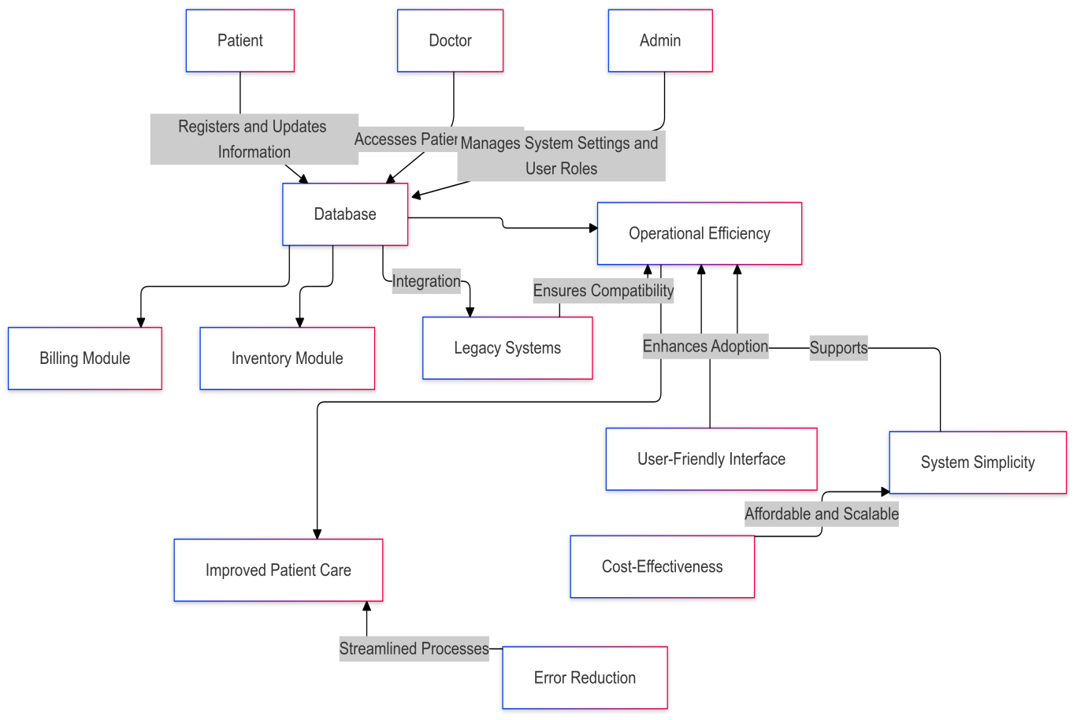

Figure 1: Conceptual Diagram

## 

# CHAPTER THREE: METHODOLOGY

## 3.1 Introduction

This chapter explains the methods used to solve the problems identified in chapter one and achieve the project’s objectives. The methodology provides a clear outline of the steps taken to design, develop and test the HMS. Starting with the research design, I chose a mixed-method approach that combines qualitative insights with quantitative data, which helps capture a comprehensive view of the current challenges in smaller hospitals. The chapter also describes data collection techniques, including case studies and document analysis, which helped gather detailed information about hospital operations and the requirements for a functional HMS. System analysis follows, where I define both functional and non-functional requirements based on user needs, then outline a system design that details the architecture, interface and database setup for the HMS. Lastly, ethical considerations are addressed to ensure the research respects participant privacy and maintains confidentiality, setting a responsible foundation for the project.

## 3.2 Research methodology/Research design used.

The research methodology used in this project combined both qualitative and quantitative research approaches to ensure a comprehensive solution to the problem of hospital management in smaller hospitals. A mixed-method methodology is appropriate as it allows for bot-in-depth qualitative insights and measurable, data-driven results.

The qualitative approach involved gathering detailed information about the challenges and needs of smaller hospitals regarding their current management systems. This was achieved through interviews with hospital staff, such as managers and IT personnel, as well as reviewing case studies and existing documentation. These insights will help understand the gaps in existing systems and provide a foundation for the new system’s design.

The quantitative approach will involve conducting surveys and analyzing existing data from smaller hospitals about the performance of their current management systems. This will provide measurable metrics such as system efficiency, error rates, and user satisfaction, which will guide the system’s development to ensure it meets the specific needs of these hospitals.

### 3.2.1 Development Methodology

The Agile development methodology will be adopted for the system’s design and implementation. This approach allows for iterative development, where the system is built in phases, each focusing on different features such as patient management, billing, and inventory control. After each iteration, feedback from hospital staff will be used to refine and improve the system. This method ensures that the final product is user-centered, flexible, and easy to implement in smaller hospital environments.

By combining these research methods and a flexible development approach, the project aims to create an efficient, affordable, and user-friendly hospital management system tailored to the needs of smaller healthcare facilities.

## 3.3 ****Data Collection Methods Used****

The tools used for secondary data collection included:

1. **Literature Review -** A comprehensive review of scholarly articles, journals, and books was conducted to provide insights into the current state of hospital management systems.
2. **Case Studies and Reports -** Detailed case studies from hospitals that implemented or struggled with hospital management systems were analyzed. These case studies helped identify recurring challenges, successes, and gaps in existing systems.
3. **Online Resources -** Government publications, healthcare organization reports, and technical blogs were examined to gather information on existing hospital systems, their adoption, and their challenges.
4. **System Documentation -** Manuals and user guides for current hospital management systems were reviewed to understand their functionalities and limitations, particularly in the context of smaller hospitals.

## 3.4 System Analysis and Design (SAD)

### ****3.4.1 System Analysis****

#### 3.4.1.1 Requirements Gathering

A structured approach was employed to gather the necessary data:

1. **Interviews:** Conducted discussions with hospital stakeholders, including administrators, medical staff, and IT personnel, to understand operational bottlenecks and expectations from the system.
2. **Surveys and Questionnaires:** Distributed among staff in small hospitals to capture feedback on current management systems and their limitations.
3. **Observation:** On-site visits to observe existing workflows and identify inefficiencies in areas such as patient registration, billing, and inventory management.
4. **Document Analysis:** Reviewed existing hospital records, system manuals, and reports to extract relevant operational insights.

#### 3.4.1.2 Requirements Analysis

The gathered information was analyzed to define the system's requirements:

1. **Functional Requirements:**
   1. Facilitate patient management, including registration, scheduling, and medical history tracking.
   2. Streamline billing, inventory control, and reporting functions.
   3. Enable integration with legacy systems for seamless migration and data consistency.
2. **Non-Functional Requirements:**
   1. The system must be user-friendly, requiring minimal training for staff.
   2. It should ensure secure handling of sensitive data through encryption and access control.
   3. Performance must be optimized to handle peak workloads without lag.
3. **Use Cases and User Stories:**
   1. Use cases describe interactions, such as a receptionist registering a new patient. Example of Use Case is A receptionist creates a new patient profile by entering details like name, contact information, and medical history.
   2. User stories illustrate specific needs. Example of User Story is "As a doctor, I need quick access to a patient's medical history to provide better treatment."

#### 3.4.1.3 Feasibility Study

The system’s feasibility was assessed in three main areas:

1. **Technical Feasibility:** Confirmed that the required development tools and platforms are accessible and suitable for the system’s design.
2. **Economic Feasibility:** Evaluated the cost of development and maintenance, ensuring affordability for small hospitals with limited budgets.
3. **Operational Feasibility:** Assessed the compatibility of the HMS with existing workflows and determined that staff could adapt to the new system with basic training.

#### 3.4.1.4 System Modeling

Models were created to visualize and document the system’s structure, behavior, and data flow:

1. **Level 0 Data Flow Diagram (DFD)**

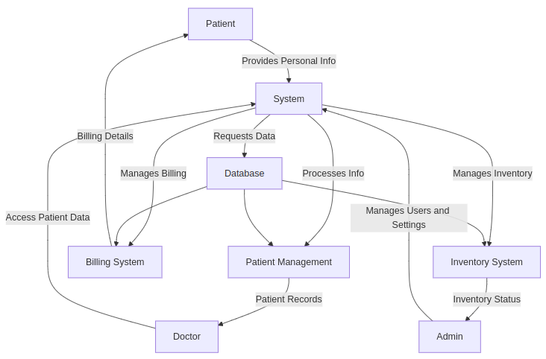

Figure 2: Level 0 DFD

1. **Level 1 Data Flow Diagram (DFD)**

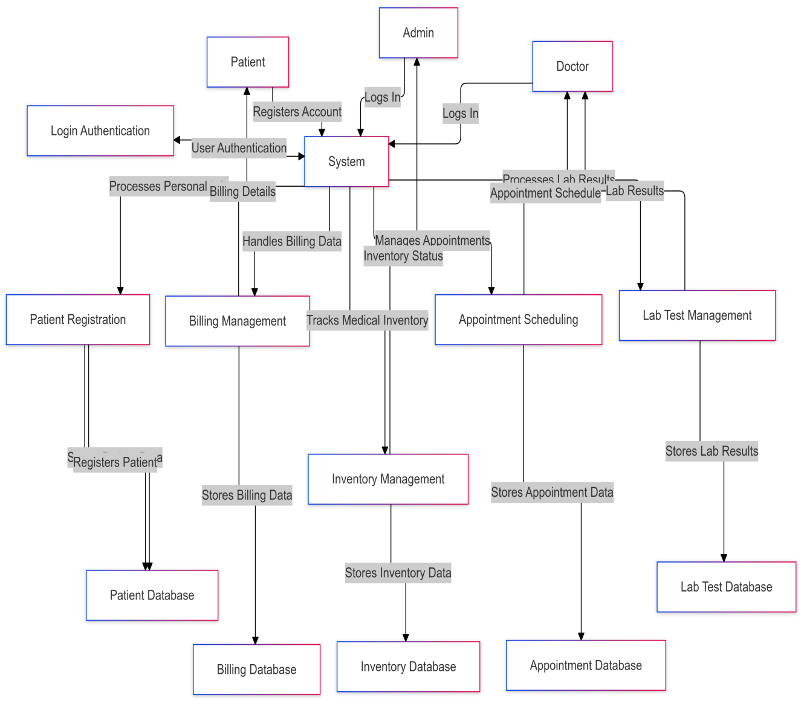

Figure 3: Level 1 DFD

1. **Entity-Relationship Diagram (ERD):**

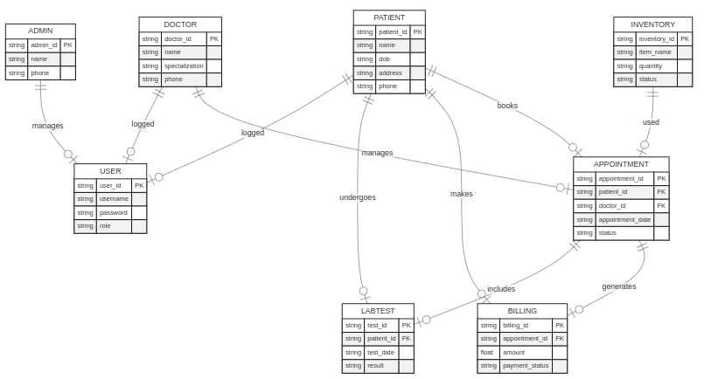

Figure 4: ER Diagram

1. **Class Diagram**

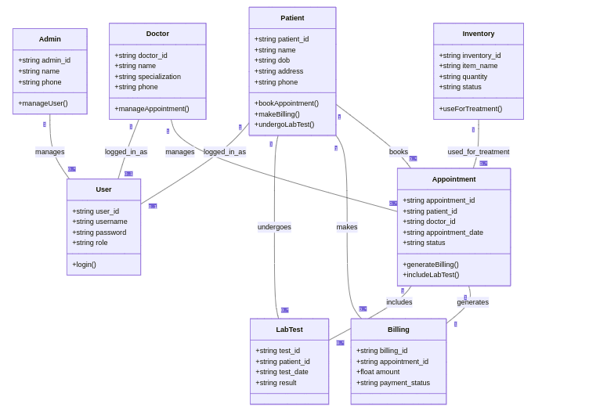

Figure 5: Class Diagram

### ****Activity Diagram****

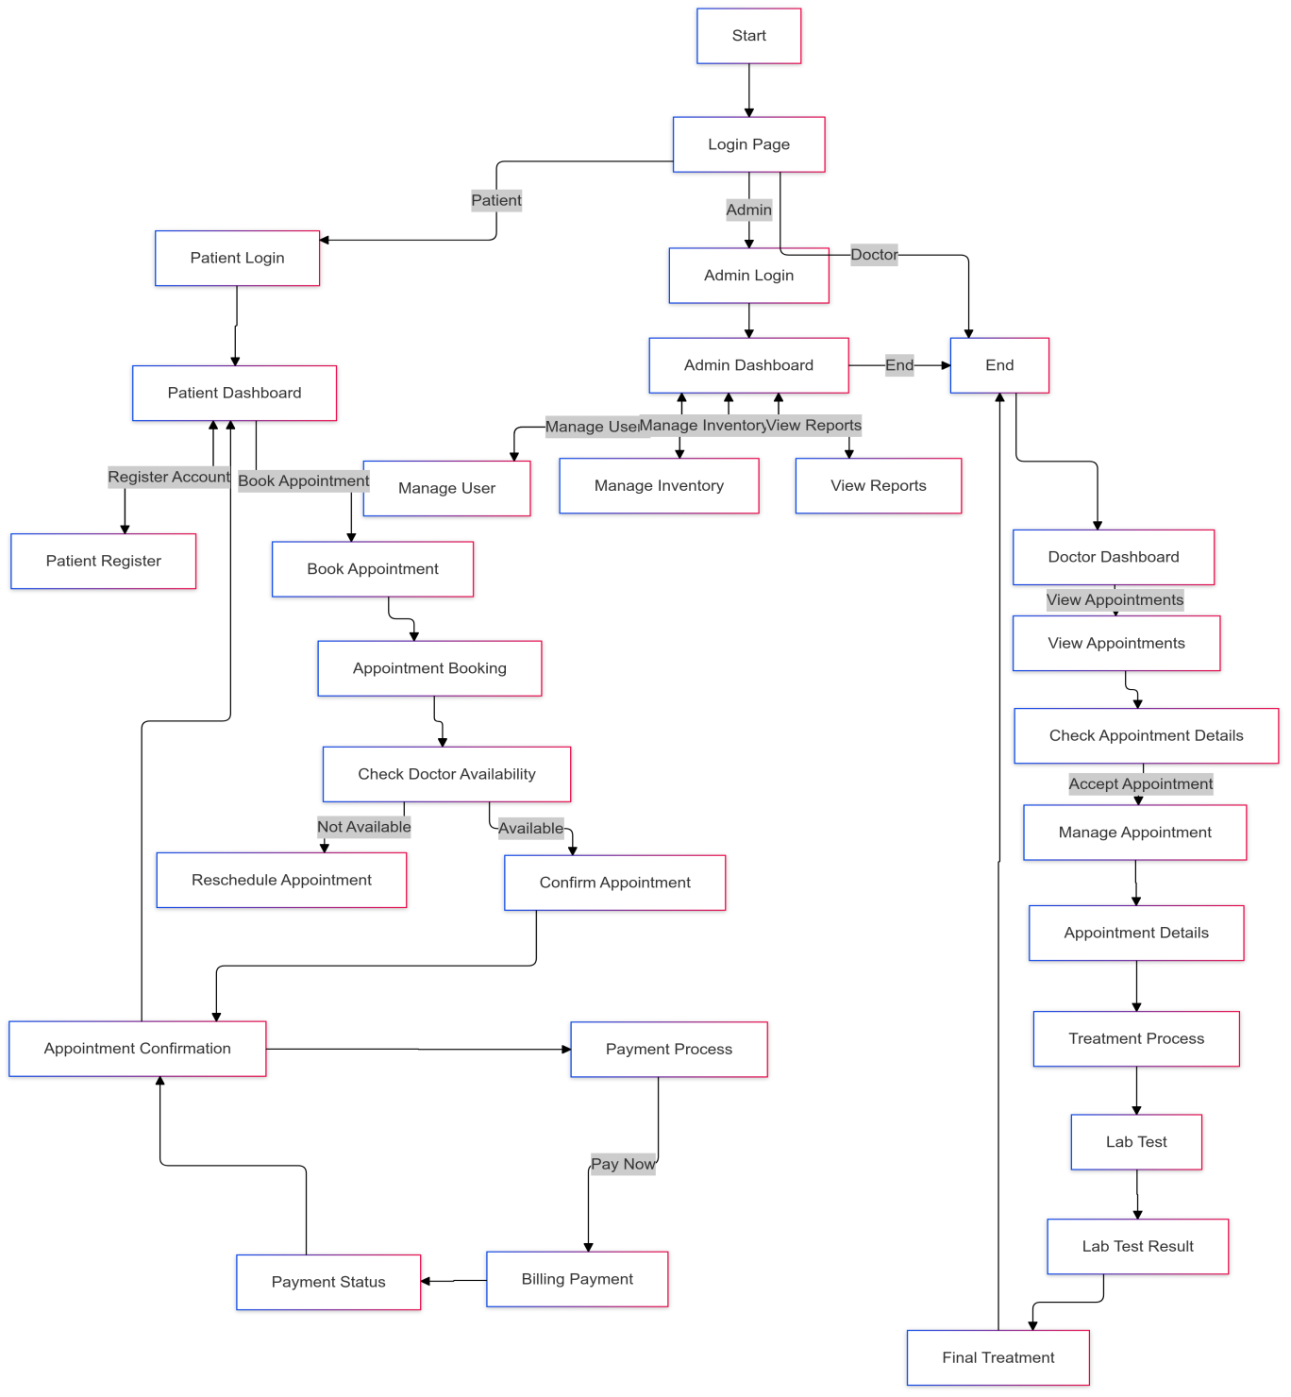

Figure 6: Activity Diagram

### ****3.4.2 System Design****

#### ****3.4.2.1 Architectural Design****

1. **System Architecture:** The system is designed as a web-based platform, hosted on cloud servers for scalability and accessibility. It includes client-side applications for end-users (doctors, patient) and a server-side backend for data processing and storage.
2. **Layered Architecture:** The HMS adopts a three-layered structure:
   1. **Presentation Layer:** Handles the user interface (UI), providing access through web browsers or mobile apps.
   2. **Business Logic Layer:** Manages the system’s core functionalities, such as patient management, billing, and inventory control.
   3. **Data Access Layer:** Facilitates interaction with the database, ensuring secure and efficient data retrieval and storage.

#### ****3.4.2.2 Detailed Design****

##### ****Component Design****

1. **Patient Management Module:** Manages patient records, appointments, and medical history.
2. **Billing Module:** Tracks payments, generates invoices, and processes financial data.
3. **Inventory Module:** Monitors stock levels of hospital supplies and automates reordering.
4. **Reporting Module:** Generates reports on hospital performance, including financial summaries and patient statistics.

##### ****Database Design****

1. **Tables and Relationships:** Tables are designed for patients, staff, inventory items, and appointments. Relationships are modeled using primary and foreign keys to maintain data integrity.
2. **Indexes and Constraints:** Indexes are added for quick query execution, and constraints ensure data validity.

##### ****User Interface Design****

1. **Wireframes:** Initial sketches outline the system’s layout, including dashboards, input forms, and navigation menus.
2. **Mockups:** High-fidelity prototypes provide detailed visual representations of the final design, focusing on aesthetics and functionality.

##### ****Algorithm Design****

1. **Appointment Scheduling:** An algorithm ensures optimal allocation of appointment slots to minimize conflicts.
2. **Inventory Reordering:** A predictive algorithm determines when to restock supplies based on usage trends.
3. **Data Security:** Encryption algorithms protect sensitive patient and hospital data during transmission and storage.

#### ****3.4.2.3 Prototyping****

##### ****Low-Fidelity Prototypes****

Initial wireframes are created to validate the system’s workflow and navigation. These prototypes help identify potential usability issues early in the design phase.

##### ****High-Fidelity Prototypes****

Interactive prototypes simulate user interactions, allowing stakeholders to evaluate the system’s look and feel. These prototypes provide a realistic preview of the final product.

#### ****3.4.2.4 Design Specification****

1. **Technical Specifications:** The HMS will run on a Linux-based server using MySQL for database management and Python (Django framework) for backend development. The frontend will use HTML, CSS, and JavaScript (React framework).
2. **Design Documents:** Includes all diagrams, descriptions, and technical explanations of the system’s architecture, components, and workflows.

#### ****3.4.2.5 Review and Validation****

1. **Design Review:** Stakeholders, including hospital representatives, will review the design documents to ensure all requirements are addressed.
2. **Validation:** The design is validated against functional and non-functional requirements to ensure completeness, correctness, and alignment with project goals.

## ****3.5 Research Ethics****

1. **Confidentiality:** All data collected will be securely stored and accessible only to authorized personnel. Personal information of participants, such as names and identifying details, will not be shared or disclosed without explicit consent.
2. **Anonymity:** To protect the identity of participants, responses will be anonymized during data collection and analysis. Any reports or publications will use aggregated data or pseudonyms to ensure individuals cannot be identified.
3. **Informed Consent:** Participants will be fully informed about the purpose of the study, their role, and any potential risks or benefits before participating. Consent forms will be provided, and participation will be entirely voluntary, with the right to withdraw at any time without penalty.

# ****REFERENCES****

Brown, R., & Ahmed, Z. (2018). Designing Low-Cost HMS for Small Hospitals. Health Informatics Research, 10(4), 102-110.

Garcia, L., & Lin, P. (2020). Improving Patient Care Through Technology: A Study of Hospital Management Systems. Health Technology Review, 22(1), 23-32.

Johnson, P., & Lee, M. (2019). Modernizing Hospital Management for Small Facilities. Journal of Medical Informatics, 14(2), 78-89.

Jones, S., Martinez, D., & Wang, Y. (2021). User-Friendly HMS Design for Improved Healthcare Management. Journal of Healthcare Technology, 23(1), 12-19.

Kumar, N., & Patel, J. (2017). Integrating Old Systems with New HMS Solutions. International Journal of Medical Informatics, 8(3), 33-45.

Miller, T., & Roberts, C. (2019). Evaluating the Impact of HMS on Healthcare Efficiency. Journal of Healthcare Systems, 17(4), 89-97.

Smith, J. (2020). Hospital Management in Small-Scale Settings: A Review of Practices. Healthcare Systems Journal, 12(3), 45-62.

Walker, T., Singh, A., & Choi, J. (2020). Transitioning from Legacy Systems to Modern Hospital Management Software. Technology in Healthcare, 15(2), 90-97.

# ****APPENDICES****

## ****Appendix 1: Budget****

|  |  |  |
| --- | --- | --- |
| **Item** | ****Estimated Cost (Kshs.)**** | ****Description**** |
| **Software Licenses** | 5,000 | Cost of IDEs, development tools (e.g., JetBrains, Microsoft Office), or other required software. |
| **Learning Materials** | 3,000 | Purchase of textbooks, online courses, or tutorials related to HMS development. |
| **Internet Costs** | 6,000 | Estimated cost for reliable internet access over the development period. |
| **Power Backup** | 10,000 | Optional: UPS or power bank to ensure uninterrupted work in case of outages. |
| **Testing Devices** |  | Testing will primarily be done on the student’s laptop, minimizing extra costs. |
| **Printing and Stationery** | 2,000 | Printing the proposal and final documentation, as well as any stationary needs. |
| **Miscellaneous Costs** | 4,000 | Travel costs for data collection, hosting meetings with stakeholders, or unforeseen expenses. |
| **Hosting/Deployment** | 3,000 | Hosting costs for testing the system (e.g., cloud services, local server setup). |
| **Total Estimated Cost** | **33,000** |  |

Table 1: Budget

## ****Appendix II: Data Collection Tools****

1. **Survey Questionnaire for Hospital Staff**  
   This tool will gather quantitative and qualitative data regarding the current hospital management systems used, challenges faced, and staff expectations. The survey will include questions like:
2. What are the primary challenges you face with the current HMS?
3. How do you manage patient data, billing, and inventory?
4. What features would you want in a new hospital management system?
5. **Interview Guide for Stakeholders (Hospital Managers/Directors)**  
   This guide will be used for one-on-one interviews to understand the managerial perspective on the current systems and what improvements are desired. Example questions:
6. What specific features do you feel are missing in your current HMS?
7. How do you evaluate the effectiveness of your hospital’s current systems?
8. What is your budget for adopting a new HMS?
9. **Observation Checklist**  
   A checklist will be used to observe the manual and existing HMS systems in smaller hospitals. It will document:
10. Manual processes being used (e.g., paper records, manual billing).
11. Areas where errors are commonly occurring.
12. Efficiency of current system workflows.
13. **Document Analysis Template**  
    This tool will be used to review existing hospital documents, manuals, and reports. It will help in identifying gaps in the current HMS and the information required for developing the new system.

## ****Appendix III: Project Schedule****

|  |  |  |  |
| --- | --- | --- | --- |
| **Phase** | **Task** | **Duration** | **Timeline** |
| **Phase 1: Planning** | Initial Research and Problem Definition | 1 week | January 2025 |
|  | Stakeholder Interviews and Surveys | 1 week | January 2025 |
| **Phase 2: Design** | System Design & Architecture | 1 week | February 2025 |
|  | Database and UI Design | 1 week | February 2025 |
| **Phase 3: Development** | System Development (Coding) | 4 weeks | February - March 2025 |
|  | Prototype Development | 1 week | March 2025 |
| **Phase 4: Testing & Evaluation** | System Testing and User Feedback | 2 weeks | March 2025 |
| **Phase 5: Reporting** | Final Report Writing | 1 week | March 2025 |

Table 2: Project Schedule